TOOT HILL VILLAGE HALL
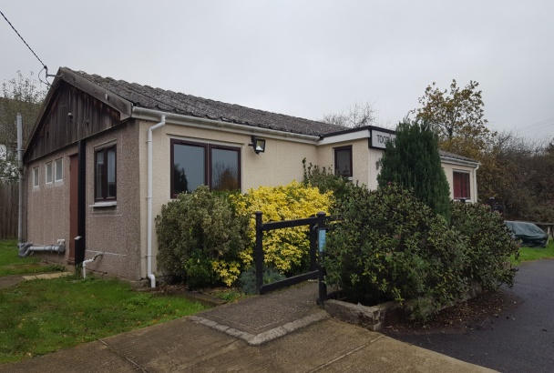
Toot Hill Road, Toot Hill, Ongar, Essex, CM5 9SD
2025/2026 Hall Hire Rates

 |  | Parishioner | Non Parishioner
Mon-Fri | 8am – 6pm | £13/hr | £16/Hr
Mon-Fri | 6pm to 12am | £14/hr | £17/Hr
Sat- Sun | 8am to 6pm | £15/Hr | £18/Hr
Sat-Sun | 6pm to 12am | £17/Hr | £19/Hr

- Regular Hall Hirers may use storage at the hall if available (and with agreement of the Parish Council) for a fee of £3/month.
- Minimum hire period of two hours for each hire. Hall hirers may not have use of the hall outside the agreed hours - hire period must include any set up and clear up needed as part of the hire.
- Full payment must be received prior to hire. Failure to receive such payment will result in the hire not being agreed. The preferred method of payment is BACS. Funds must be cleared in the Parish Council’s account prior to any hire.
- Hirers are able to provide their own public liability insurance, and a copy of this certificate should be provided to the Parish Clerk prior to hire. If no public liability insurance is in place, a fee of 10% of the total hire fee will be added to each hire for said cover (a copy of full details regarding this can be obtained from the Parish Clerk).
- Bouncy Castles or inflatables are not permitted.
- The Hall must be left in a clean and tidy order.
- All rubbish must be taken away after hire and disposed of by the hirer themselves.
- The Parish Council may require a security deposit of up to £250.00 to be held in case of any damage. This will be returned to the hirer following a check of the hall to ensure no damage has occurred.
- Any music must be turned off by 11.30pm, and the hall and car park fully vacated by 12am out of respect for neighbouring residents.
- An invoice will be sent for each hire, which include details on how to make payment.
Cancellation
Regular hall hirers are required to give 48 hours notice of cancellation, and occasional hall hirers required to give 2 weeks notice of cancellation, both with 100% of costs being retained if cancelled after this period.
April 2026

