STANFORD RIVERS PARISH COUNCIL
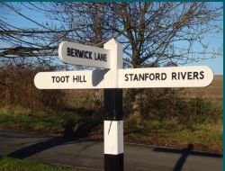

Postal Address: Ware Farm, The Street, High Roding, Essex, CM6 1NT

Tel: 077 377 36365 Email: clerk@stanfordrivers-pc.gov.uk

Clerk to the Council.

Adriana Jones

2025/2026 AUDIT - EXPLANATORY NOTE

This note is to accompany the 2025/2026 AGAR documentation to explain the ‘NO’ answers to boxes 2 and 5 of Section 1 – Annual Governance Statement 2025/2026.

The Parish Council completes an annual review of all its policies and procedures, including Risk Assessment, Standing Orders, and Financial Regulations at its March Meeting. For the 2025/2026 year, this review was scheduled to take place at the 25th March 2026 meeting. The process is that the Clerk completes a review of the policies and sends out any proposed alterations or amendments to Councillors separately prior to the meeting, to allow them time to review and consider the changes before the meeting. Both the IT Policy and Accessibility Statement has been sent, however before the other documents could be sent, the Clerk’s father fell seriously ill and was hospitalised. As a result, the Clerk did not have time to send out the remaining documents prior to the meeting (see extract from minutes below). As such, these specific items were deferred to the May 2026 meeting (at which they were duly considered and adopted – see minute reference P14.1494).

[extract from 25th March 2026 Parish Council meeting minutes]

