Land Ownership / Leases

Stanford Rivers Parish Council

Introduction
The following are details of land ownership relating to Stanford Rivers Parish Council, for the purposes of compling with the Transparency Code 2015. Details published include:
Details of all land and building assets including:
- all service and office properties occupied or controlled by user bodies, both freehold and leasehold
- any properties occupied or run under Private Finance Initiative contracts
- all other properties owned or use, for example, hostels, laboratories, investment properties and depots, garages unless rented as part of a housing tenancy agreement
- surplus, sublet or vacant properties
- undeveloped land
- serviced or temporary offices where contractual or actual occupation exceeds three months, and
- all future commitments, for example under an agreement for lease, from when the contractual commitment is made.

TOOT HILL VILLAGE HALL
The Parish Council owns and maintains the Toot Hill Village Hall, Toot Hill Road, Toot Hill, Essex CM5 9LR.
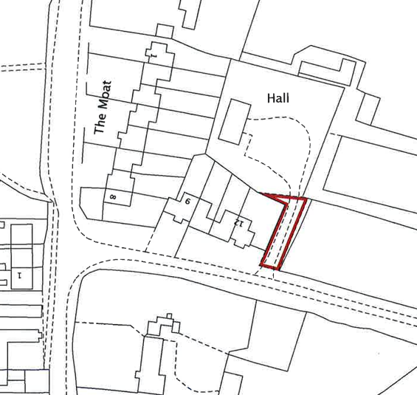
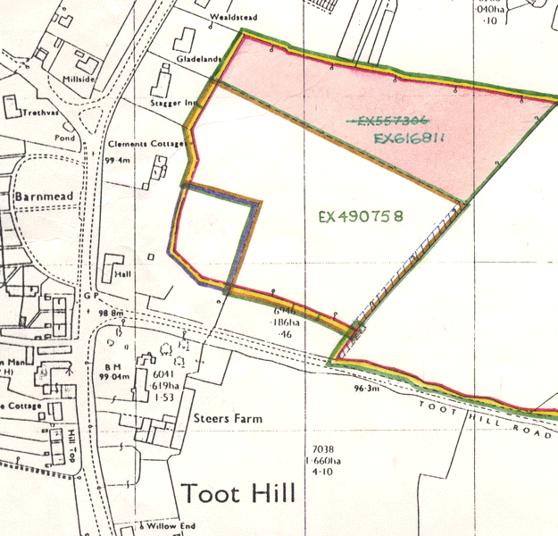

TOOT HILL VILLAGE GREEN (Sharps Green)
The Parish Council owns and maintains the Toot Hill Village Hall, Toot Hill Road, Toot Hill, Essex CM5 9LR.

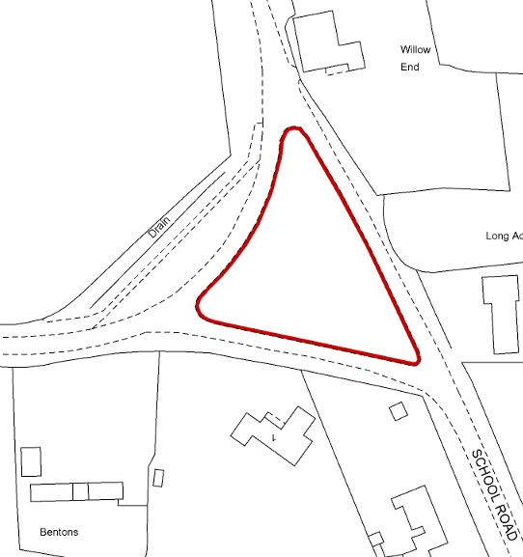

JUBILEE GREEN, LITTLE END
The Parish Council owns a small section of Jubilee Green, and leases the remainder from Essex County Council.
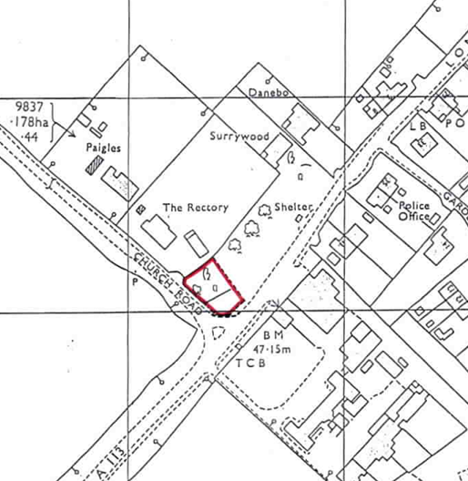
Owned by SRPC Leased from ECC
